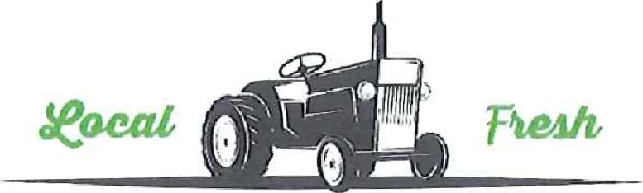
Ledyard Farmers Market
Hold Harmless Agreement

I _______________________(Guardian name) shall fully indemnify, defend and hold harmless the Town of Ledyard and all of their respective officers, employees, agents, and volunteers to the fullest extent allowed by law for any claim for personal injury, bodily injury, death, property damage, emotional injury or any other injury, loss or damage of any kind occurring during the term of the agreement and alleged to have been caused in whole or in part by
(Child Name), and even if caused by the negligence of the Town of Ledyard or any of their officers, employees, agents, and volunteers.
Dated:

